Question 3
On January 1, 20X5, Juan Silvia borrowed $500,000 to purchase a new office building. The loan is to be repaid in 2 equal annual payments, beginning December 31, 20X5. The annual interest rate on the loan is 9%.
Prepare the appropriate journal entries to record the loan and subsequent payments at the end of 20X5 and 20X6.

Question 4
Jacob Joseph has identified five different companies in which he is interested in investing, based upon their products and prospects. However, Jacob is concerned about a general economic downturn and desires to invest in companies with the lowest debt exposure. Following is a list of the data for the five potential investments. Jacob has compiled the data and has ranked the companies based upon total debt. He has requested your help in evaluating the risk profiles for each company.
To complete your evaluation, you need to know that each company faces an income tax rate that is equivalent to 30% of income before taxes (which also means that net income is 70% of income before taxes). In addition, assume that each company incurs an average interest cost that is 8% of total debt.
 | Total Assets |  | Total Debt |  | Net Income
A | $ 10,000,000 |  | $ 1,000,000 |  | $ 200,000
B | 20,000,000 |  | 3,000,000 |  | 1,000,000
C | 6,000,000 |  | 4,000,000 |  | 250,000
D | 15,000,000 |  | 6,000,000 |  | 1,600,000
E | 30,000,000 |  | 22,000,000 |  | 4,000,000
- Calculate the debt to total asset ratio, and reorder the list from least risky to most risky, based upon that ratio.
D
C
B
E
A

Question 5
Jacob Joseph has identified five different companies in which he is interested in investing, based upon their products and prospects. However, Jacob is concerned about a general economic downturn and desires to invest in companies with the lowest debt exposure. Following is a list of the data for the five potential investments. Jacob has compiled the data and has ranked the companies based upon total debt. He has requested your help in evaluating the risk profiles for each company.

To complete your evaluation, you need to know that each company faces an income tax rate that is equivalent to 30% of income before taxes (which also means that net income is 70% of income before taxes). In addition, assume that each company incurs an average interest cost that is 8% of total debt.
 | Total Assets |  | Total Debt |  | Net Income
A | $ 10,000,000 |  | $ 1,000,000 |  | $ 200,000
B | 20,000,000 |  | 3,000,000 |  | 1,000,000
C | 6,000,000 |  | 4,000,000 |  | 250,000
D | 15,000,000 |  | 6,000,000 |  | 1,600,000
E | 30,000,000 |  | 22,000,000 |  | 4,000,000
Calculate the debt to equity ratio, and reorder the list from least risky to most risky, based upon that ratio.
Question 5 options:
C
E
A
B
D

Question 7
Stanley Corporation has no material problem with uncollectible accounts or obsolete inventory. All sales and purchases are on account. The company provided the following information for the year ending 20X7:
Total sales | $ 2,600,000
Beginning accounts receivable | 700,000
Total purchases of inventory | 1,800,000
Beginning inventory | 50,000
Collections on accounts receivable | 2,400,000
Payments on accounts payable | 1,850,000
Cost of goods sold | 1,775,000
Calculate the accounts receivable turnover ratio.
A) | 2.50

B) | 3.25

C) | 4.00

D) | 3.50

Question 8
Stanley Corporation has no material problem with uncollectible accounts or obsolete inventory. All sales and purchases are on account. The company provided the following information for the year ending 20X7:
Total sales |  | $ 2,600,000
Beginning accounts receivable |  | 700,000
Total purchases of inventory |  | 1,800,000
Beginning inventory |  | 50,000
Collections on accounts receivable |  | 2,400,000
Payments on accounts payable |  | 1,850,000
Cost of goods sold |  | 1,775,000
Calculate the inventory turnover ratio.
31.2
30
28.5
28.4

Question 9
Which type of cash flow activity is applicable for the activity listed below, operating, investing financing or non-cash?
Issue common stock for cash

Question 10
Which type of cash flow activity is applicable for the activity listed below, operating, investing financing or non-cash?
Issue common stock for land

Question 11
Which type of cash flow activity is applicable for the activity listed below, operating, investing financing or non-cash?

Sell goods for cash

Question 12
Which type of cash flow activity is applicable for the activity listed below, operating, investing financing or non-cash?

Purchase equipment for cash

Question 13
Which type of cash flow activity is applicable for the activity listed below, operating, investing financing or non-cash?

Pay employee salaries

Question 14

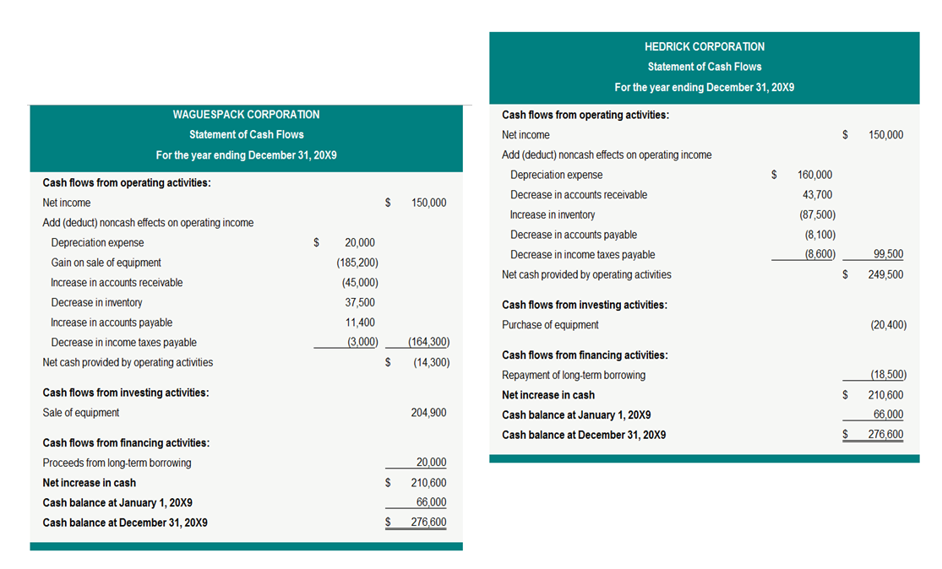
Waguespack Corporation and Hedrick Corporation had identical cash positions at the beginning and end of 20X9. Each company also reported a net income of $150,000 for 20X9. Evaluate their cash flow statements that follow. Which company is displaying elements of cash flow stress? What factors cause you to reach this conclusion? What is the importance of evaluating a company's cash flow statement?

Question 15
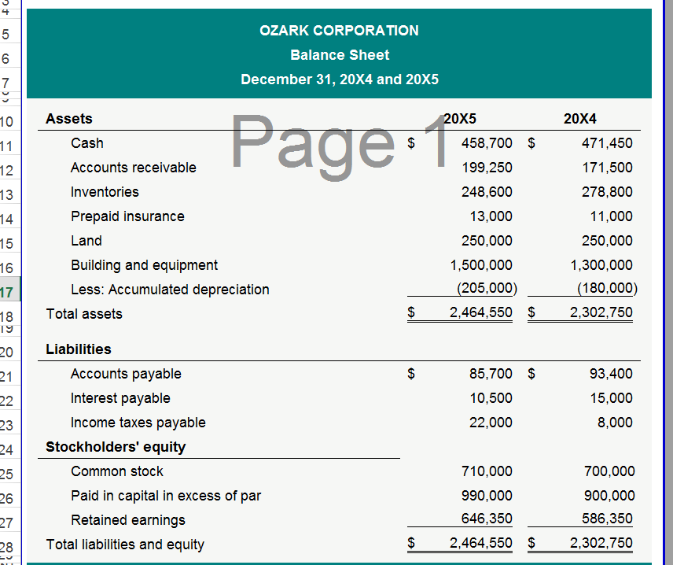

Ozark Corporation did not sell any equipment during the year. Equipment purchases were made with cash. The change in retained earnings is attributable to net income and dividends. The increase in common stock and additional paid-in capital is due to issuing additional shares for cash.
Using the indirect approach, prepare the INVESTING AND FINANCING sections of the statement of cash flows for Ozark for the year ending December 31, 20X5. Comparative balance sheets for Ozark are above.
Question 16

Vintage Furniture constructs and sells executive style conference tables. The selling price is $10,000 per table. A unique feature is that the only raw material used in the construction of each table, other than indirect materials like glues and screws, comes entirely from a single tree. Tree prices and other costs of production have remained stable, and Vintage is able to use each tree purchased without incurring any significant spoilage. Consider the following "disorganized" information and complete the indicated requirements.
 | Ending work in process (600 tables) | $ 1,800,000
 | Selling price per table | 10,000
 | Ending finished goods (200 tables) | 1,400,000
 | Indirect labor incurred during the period | 125,000
 | Raw materials transferred into production (700 trees) | 700,000
 | Beginning finished goods (400 tables) | 2,800,000
 | Cost of glues and screws | 35,000
 | Beginning work in process | 1,465,000
 | Ending raw materials (500 trees) | 500,000
 | Direct labor incurred during the period | 3,300,000
 | Selling, general, and administrative costs incurred | 1,150,000
 | Depreciation of factory equipment | 75,000
 | Raw material purchases during the period (900 trees) | 900,000
 | All other factory overhead | 300,000
 | Tables sold (800 tables)
(a) | Complete the reconciliation of units on the accompanying blank worksheet, showing the "unit" activity in raw materials, work in process, and finished goods.
(b) | Calculate the cost of goods manufactured.
(c) | Calculate the cost of goods sold.
(d) | Calculate net income. Assume an income tax rate of 35%.

